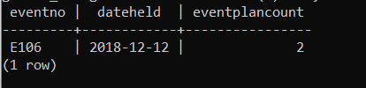

SELECT

eventrequest.eventNo,

eventrequest.dateHeld,

COUNT(\*) AS eventPlanCount

FROM EventRequest AS eventrequest

INNER JOIN EventPlan AS eventplan ON eventrequest.eventNo = eventplan.eventNo

WHERE eventplan.workDate BETWEEN '2018-12-01' AND '2018-12-31'

GROUP BY eventrequest.eventNo

HAVING COUNT(\*) > 1;